**Lab Exercise 2**

**AIM: Method overloading and Overriding**

**1. Overloading**

class Overloading

{public void wish(char c)

{ System.out.println(c); }

public void wish(char c,int x)

{

System.out.println(c + " " +x);

}

}

class Shraddha

{ public static void main(String args[])

{

Overloading obj = new Overloading();

obj.wish('s');

obj.wish('s',18);

}

}

**ALGORITHM:**

1. Create a class Overloading.

2. Define a method wish inside it with parameters char c.

3. define another method with paarameters char c and int x.

4. Create a class Shraddha

5. In main method Craete an object obj.

6. Call the respective method by giving respective inputs as parameters of methods.

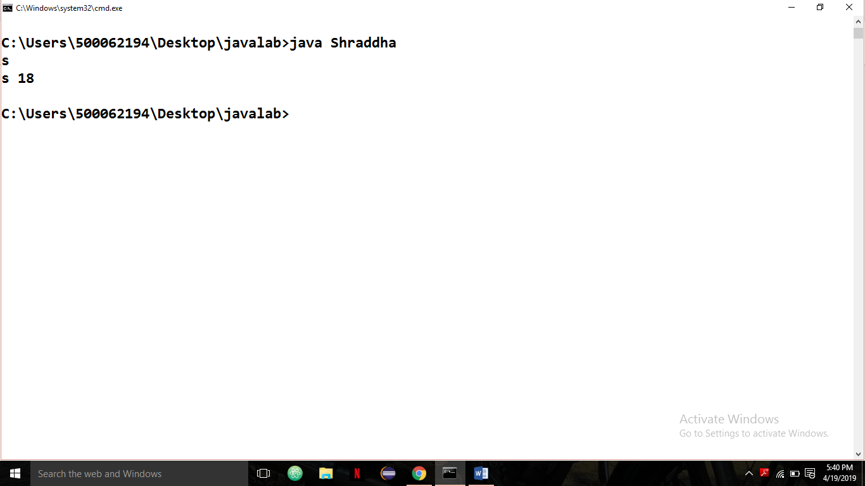

**2. Overriding:**

class Parent{

public void method1(int a,int b){System.out.println("Ans:"+(a+b));}

public void method2(){System.out.println("Parent");} }

class Child extends Parent{

public void method1(char a,char b){System.out.println("Ans: "+(a+b));}

public void method2(){

System.out.println("CHild");

}}

class Main02{

public static void main(String args[]){

Parent obj1 = new Parent();

obj1.method1(1,2);

obj1.method1('b','a');

obj1.method2();

Child obj2 = new Child();

obj2.method2();

}}

ALGORITHM:

1. Create a Parent class and define two methods method1 and method2.

2. Similarly Create a Child Class inherited by Parent and create two methods method1 and method2.

3. Create Main Class and inside it Create two objects, one with reference of Parent and other with child.

4. With object 1, call methods of Parent class.

5. With object 2, call methods of Child class.

